ROOT DIJAGRAMA

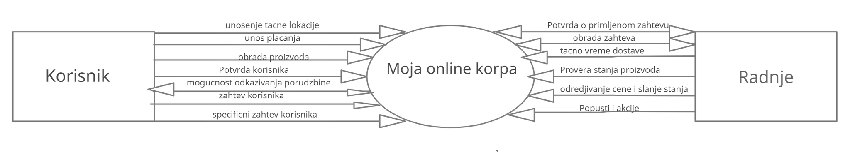

SSA 1 KORAK

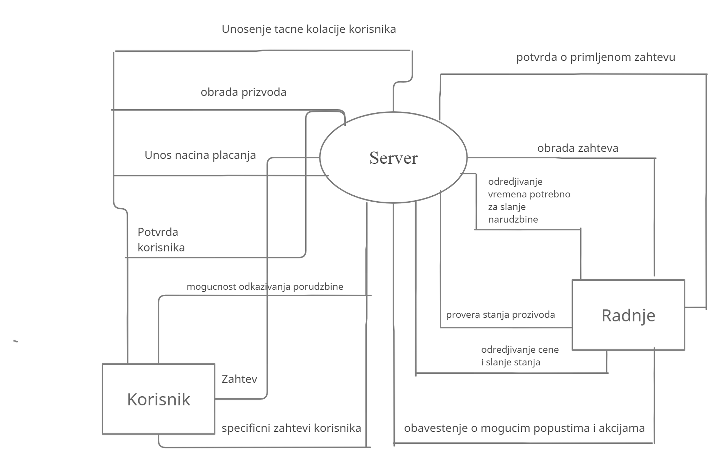

SSA 2 KORAK

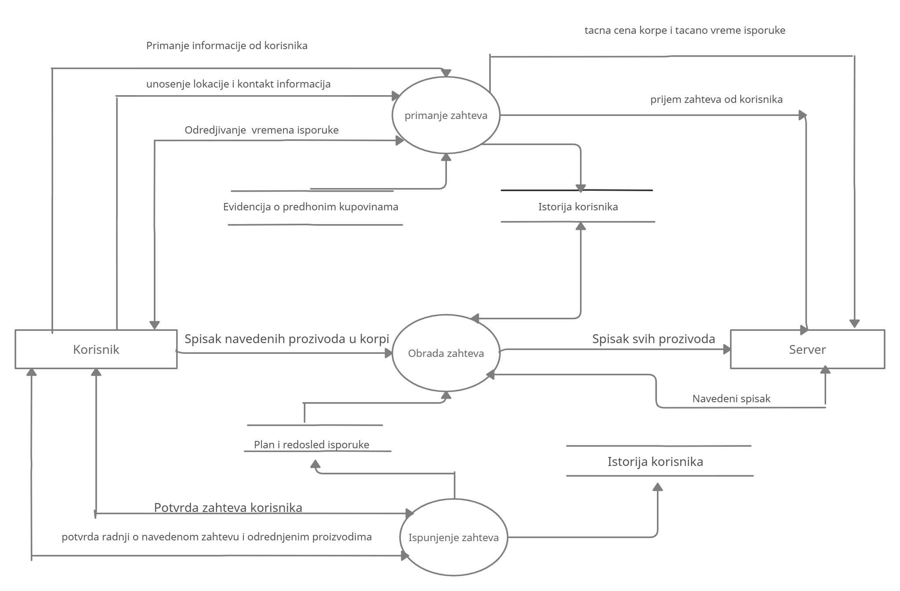

SSA 3 KORAK

